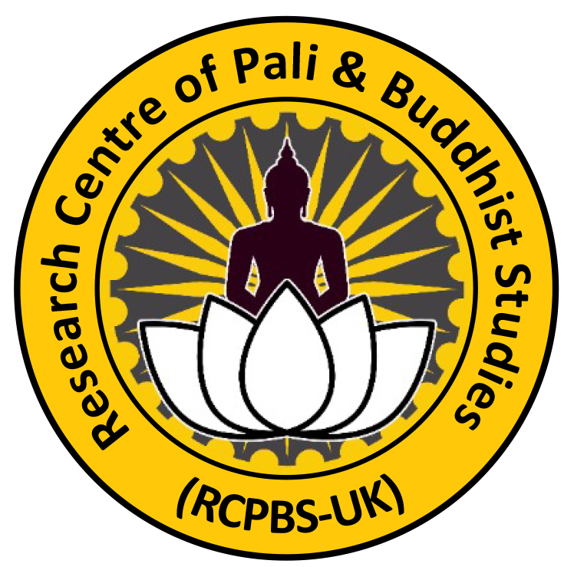

Research Centre of Pali & Buddhist Studies in UK (RCPBS)
ELEMENTARY BUDDHIST COURSE
APPLICATION FORM – 2024

Please complete form and return to: info@rcpbs.uk

Name

Phone number ………………………… | Email …………………………………….

Address
………………………………………………………………………………………………
………………………………………………………………………………………………

Date of birth……………………... | Nationality…………………………………..

Present situation:
What are you doing at present? Are you involved in Buddhist Courses or any related work? Please give details.

Experience:

Education and qualifications:

Other relevant experience:

Buddhist practice:

Connection to Buddhist groups:
Do you practice regularly in one tradition? Have you made any formal commitment or taken ordination?

Is there anything else we should know?

Course Fees
Each session will be one hour long, and the entire course will cover 40 hours of insightful content. To cover the operational costs of maintaining our resident monks, renting the premises, utilities such as electricity and gas, and spend for charity programmes with Foundation of Radiance of Dawn in Sri Lanka. we kindly request a donation of £20 per hour from each participant.

Account Details
Account Name: Thittagalle Arunasiri
Sort Code : 30-94-97
Account : 17801763

Application date: …………………..

Signature:……………………….

